**Welcome to QuiNZical!**

The quiz app that asks you questions about New Zealand.

Although designed with keeping young adults new to New Zealand in mind, to help them learn about New Zealand, it is a quiz application that can be played by all.

So, whether you’re here to play to learn about New Zealand trivia, culture, and history, or to test your veteran knowledge, this is the app for you!

**To play the game:**

Make sure the categories folder and the quiNZical.jar file are in the same directory, as well as quiNZical.sh.  
DO NOT DELETE ANY OF THE FILES IN THE categories FOLDER, IT MUST HAVE AT LEAST 5 FILES, NOR DELETE ANY LINES ALREADY EXISTING IN THE FILES, THERE MUST BE AT LEAST 5 FILES.

**To run:**

Open the terminal in that directory and copy paste and run the following command in it to run QuiNZical:

$$./quiNZical.sh$$

(In case it doesn’t work you will need to give it executable rights and then run by entering the following command instead: $chmod +x quiNZical.sh; ./quiNZical.sh$)

**Hamburger Menu:**

Toggle the hamburger menu to get the options for ‘NZ QUESTIONS’, ‘VIEW SCORE’, ‘PRACTICE’, ‘LEADERBOARD’, and ‘RESET’.

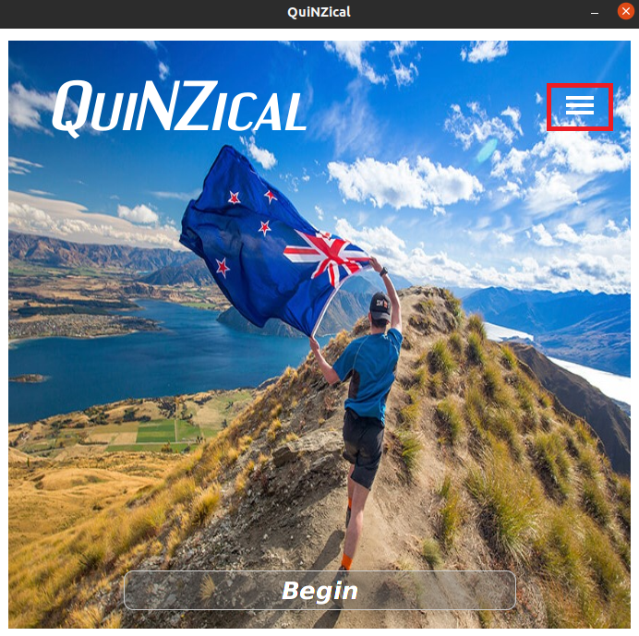

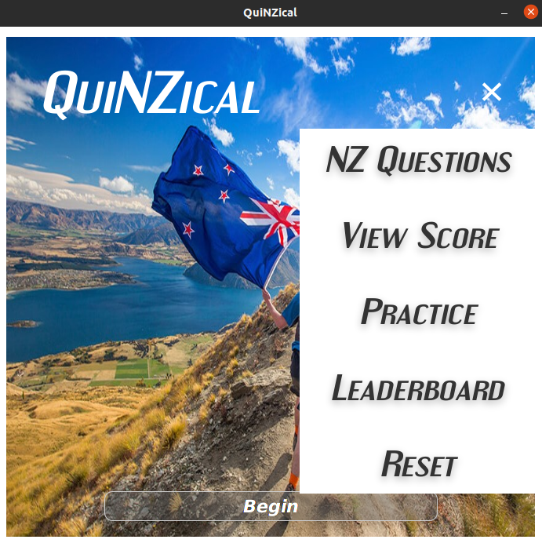

**Begin:**

This will begin/continue the QuiNZical game!

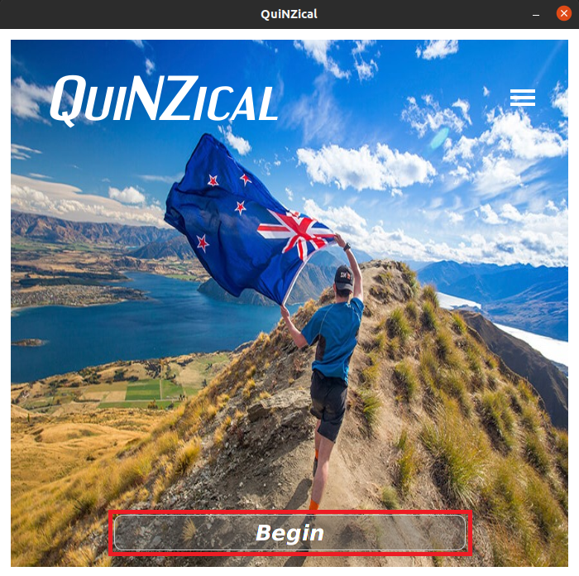

**Games module:**

By pressing the ‘Begin’ button or going to the hamburger menu and selecting ‘NZ Questions’ you will be able to begin the game. You will then choose 5 categories, from which the questions will be asked. Then the game will begin and take you to the question board.

**Question Board:**

In the games module you will have a table of questions. There will be 5 columns, one for each category you selected. The first row will have the name of the category, after which the following 5 rows will be questions randomly selected from the category.  
You will be able to answer questions from any category, but you will go in the order of low to high value questions, i.e. questions will range from $100 to $500 - you will only be able to do the $100 one initially; then the $200 after you answer the $100 one for the category, and so on. As you answer each question it is removed from the question board.

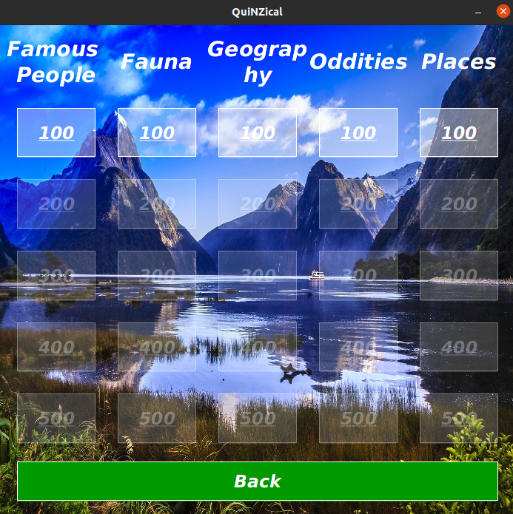

**Answering questions:**

Once you select a category you will be taken to the answering screen. The clue/question will play out and you can answer it.

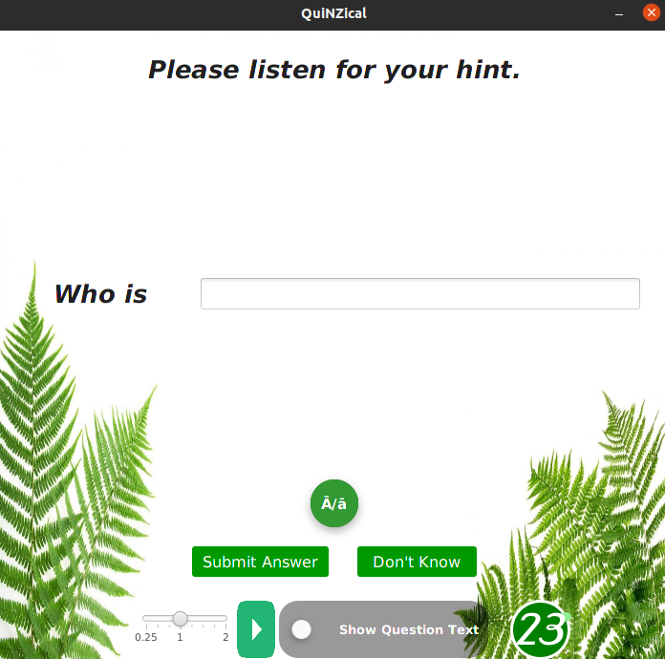  
If you want to play the clue/question at a different speed, just adjust the speed bar and click the play button again.

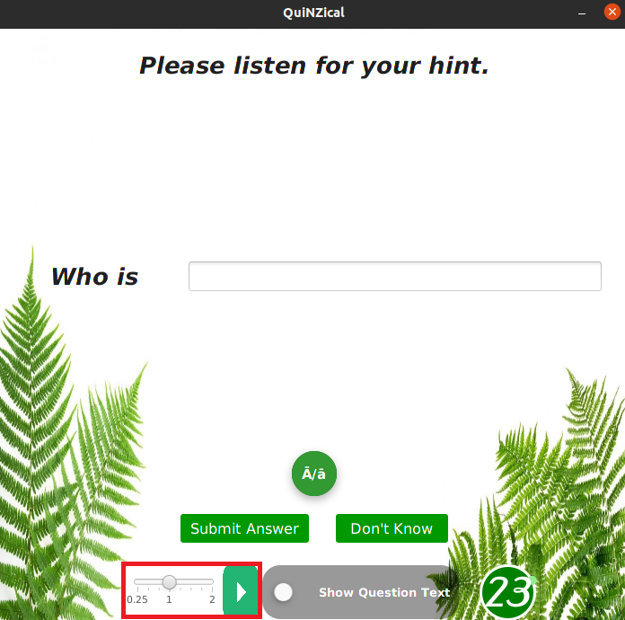

You can toggle to see the clue/question as well.

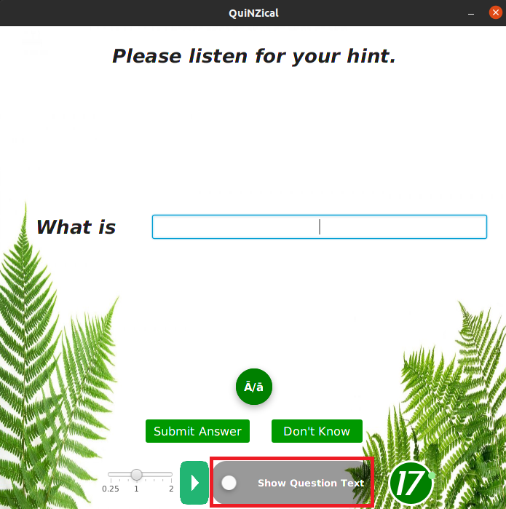

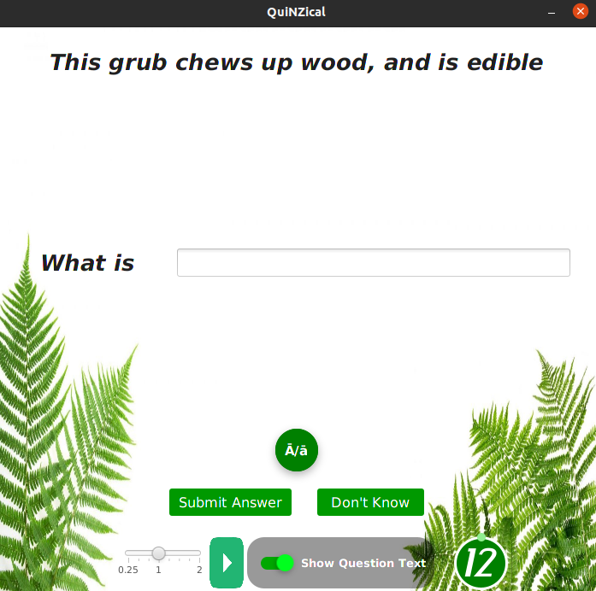

There will be a timer counting down - this shows the time you have to answer the question. To answer the question just type the answer in the text box and click submit.

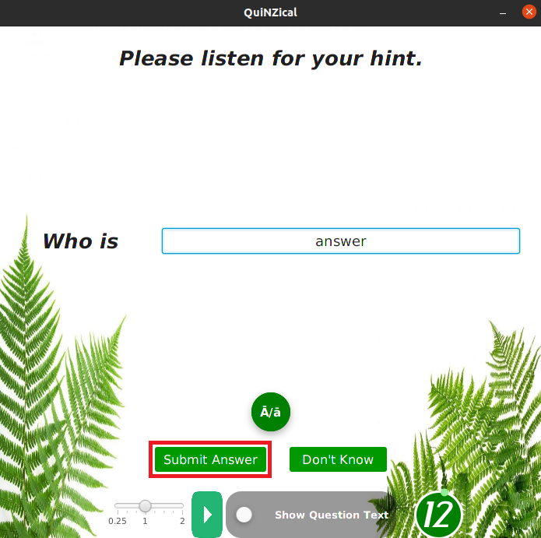

**Answering questions with multiple answers/various possible answers:**

If the clue you have has multiple answers, for e.g. “The colour of the All Blacks Jersey”, you can answer “Black, White”, or, “White, Black”; both will be marked correct - i.e. the order does not matter, just separate each of the options by a comma.

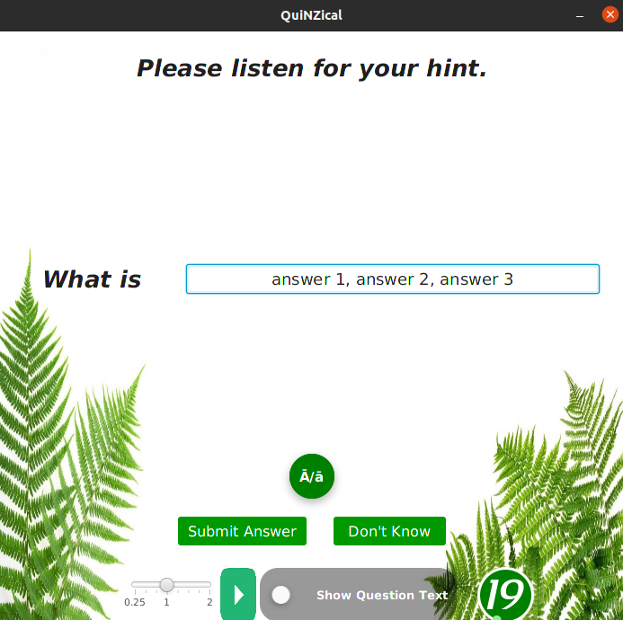

If the clue can have various potential answers, for e.g. “One colour in the All Blacks Jersey”, you can answer “Black/ White”, “White/Black”, “White”, or “Black”; they will all be marked correct.

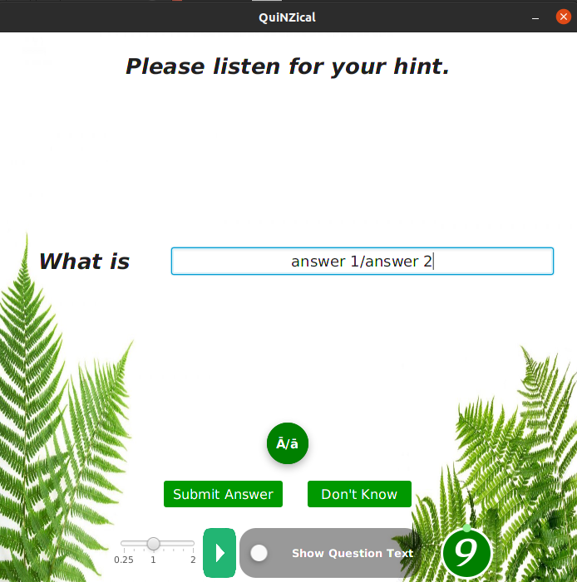

In case your clue has multiple answers, but has variations, for e.g. “Two colours in the New Zealand flag”, then any of the answers “Blue, Red”, “White, Red”, or “White, Blue” will be correct - and again order does not matter.

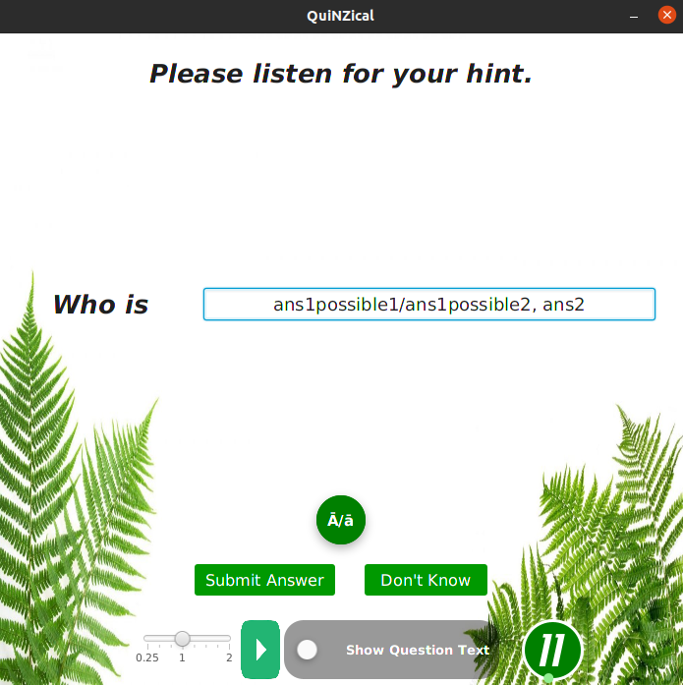

**Practice:**

The practice module is where you can hone your New Zealand skills. Navigate to the hamburger icon on the home screen, then select “Practice Module”. On the next screen, choose a category, and you’ll be taken to a random question. From here, you can attempt it. On your 3rd attempt, you’ll be given the first letter as a prompt in the text box. On the fourth, you’ll be given the answer, both in text and audio. You still have to type it in for practice though!

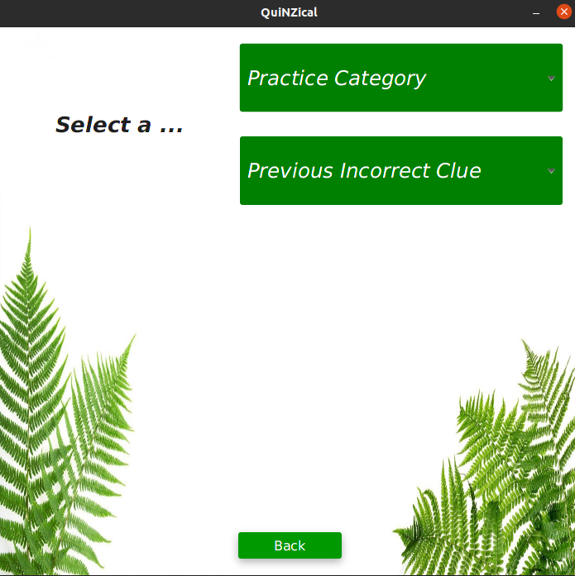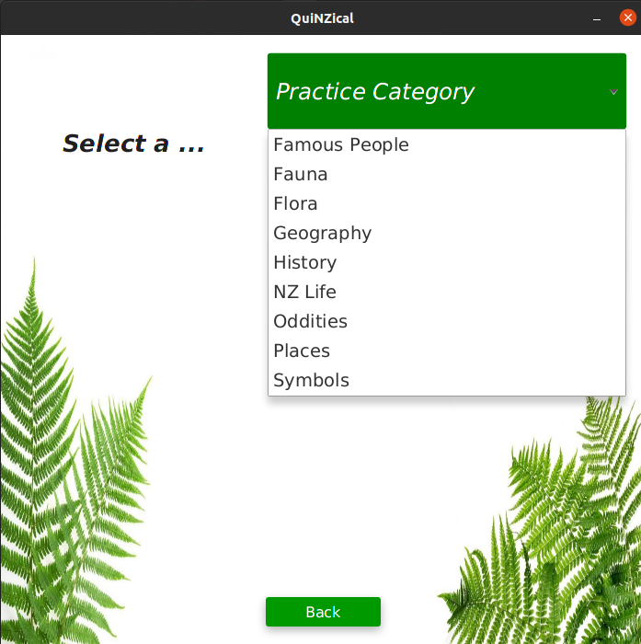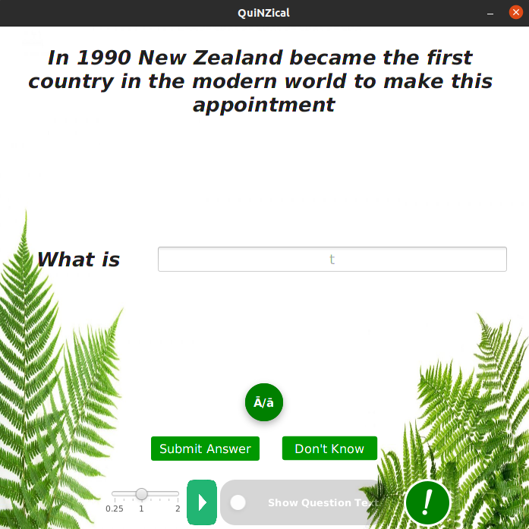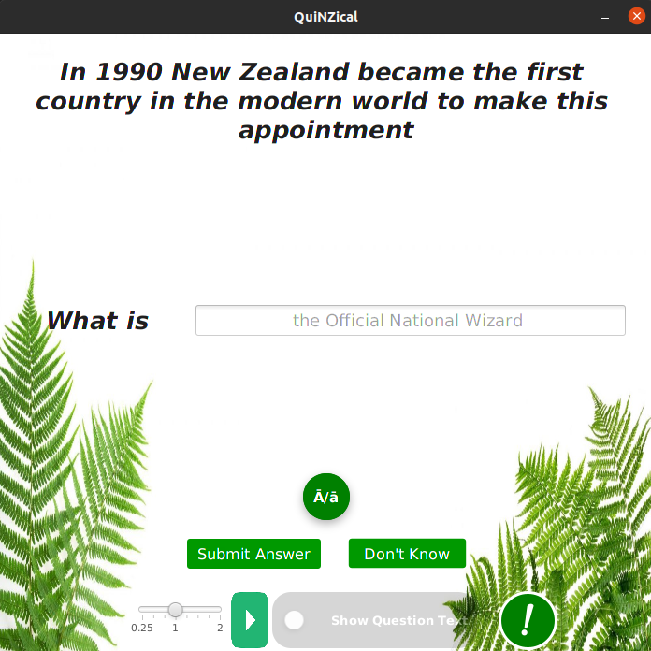

If you get clues/questions wrong in the games module, they are recorded for you to attempt in the practice module.

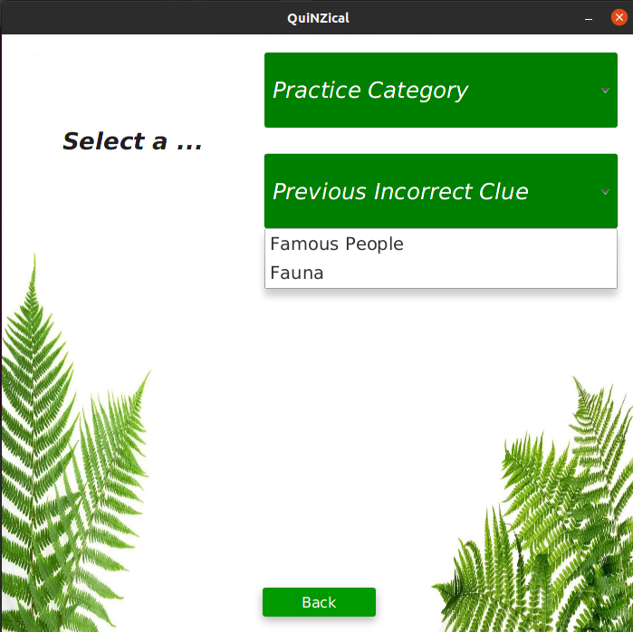

**View Winnings:**

You can view your current game winnings anytime from the menu.

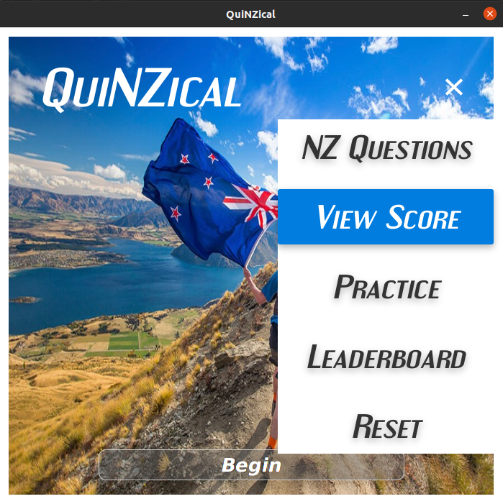

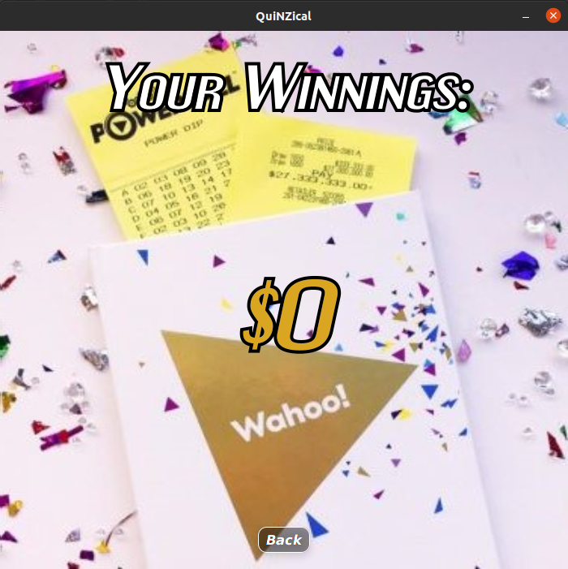

**Leaderboard:**

At the end of each game you can save your total winnings with your name, which will be recorded on the leaderboard.

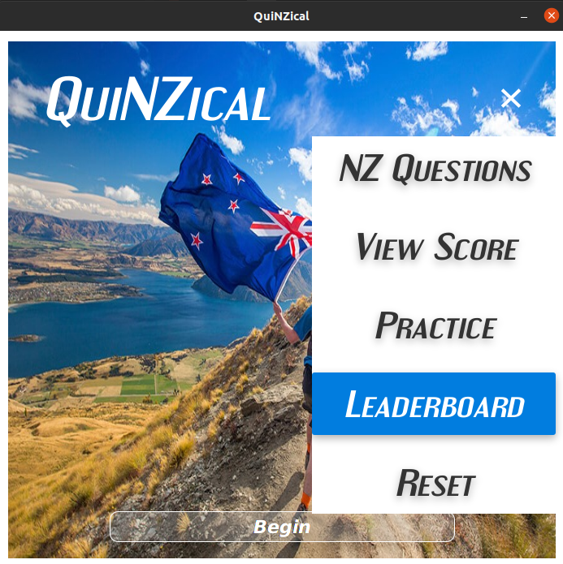

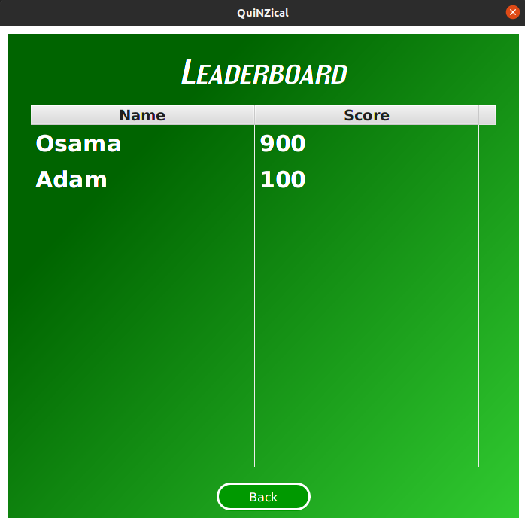

**Reset:**

You can reset your progress anytime from the menu.

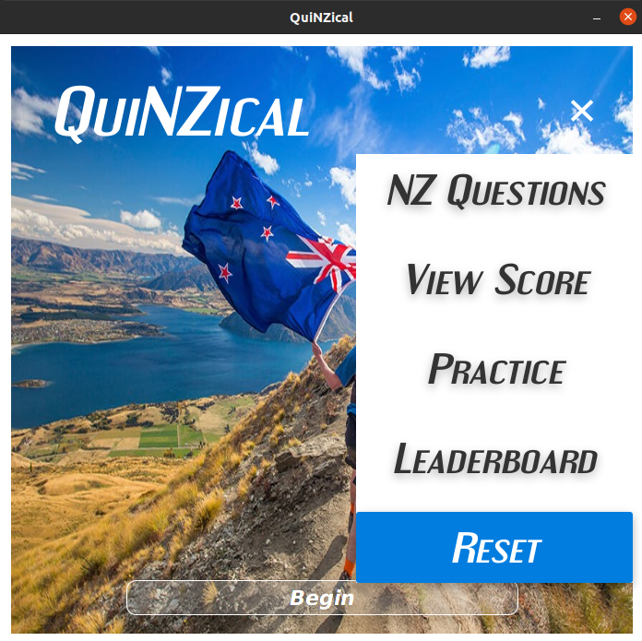

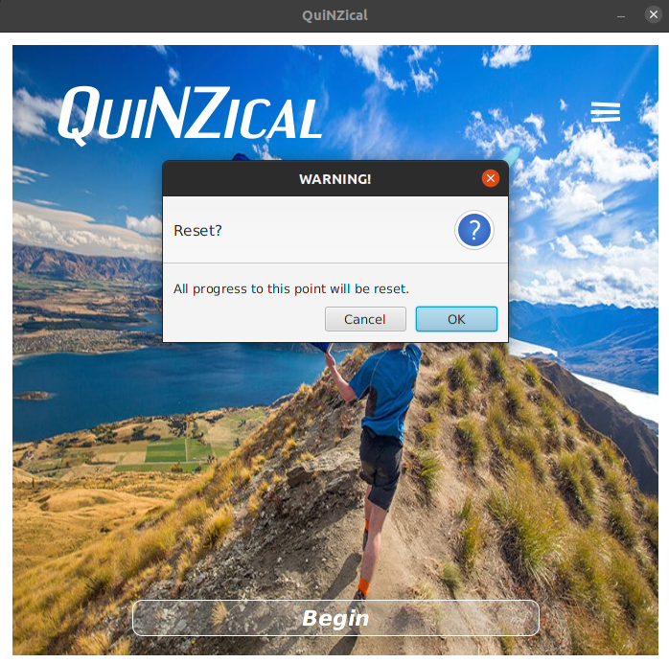

**International Section:**

An International section gets unlocked once you have completed two categories in the NZ Questions Section.

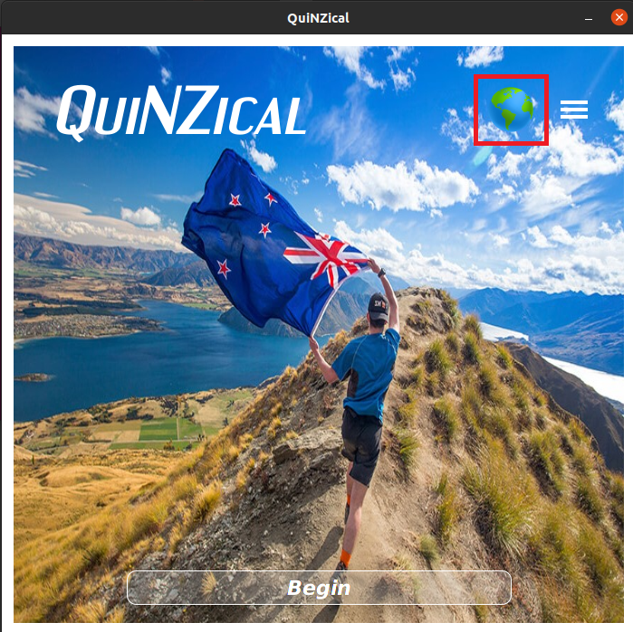

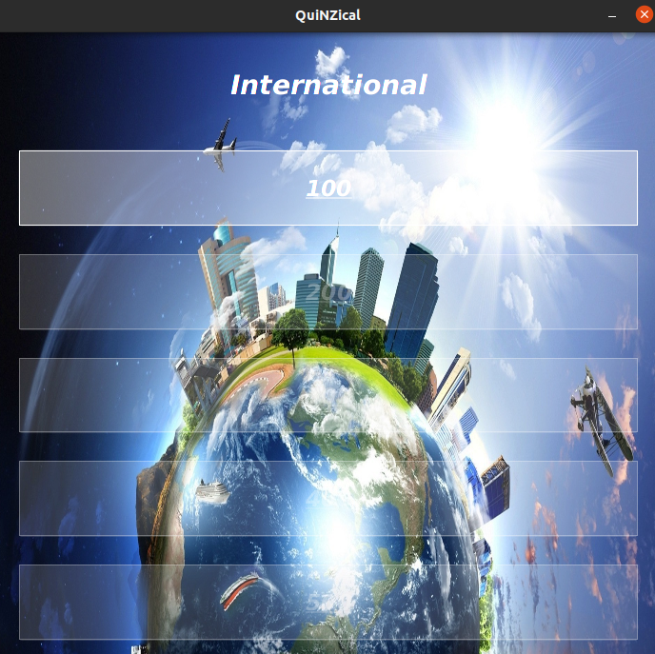

**Exiting the Game**

Just click the x at the top right. It closes the application. Fear not though, all your hard work is preserved!

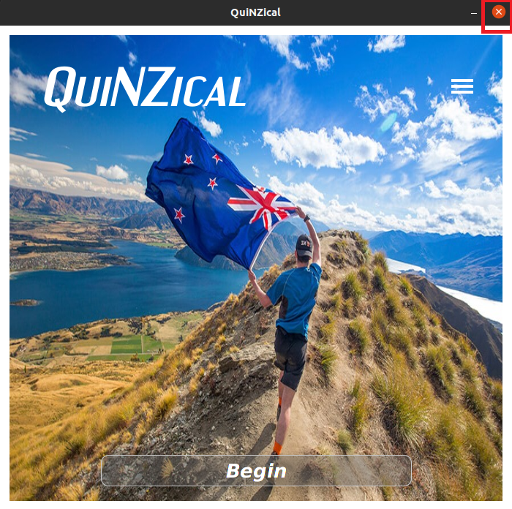

**Adding new categories:**

Go to the categories folder and make a new file, naming it with the name of the category you want.  
Add questions to it from the Text Editor - how to do this is shown below.  
Your category file will need to have at least 5 questions for it to come into the game.

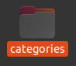

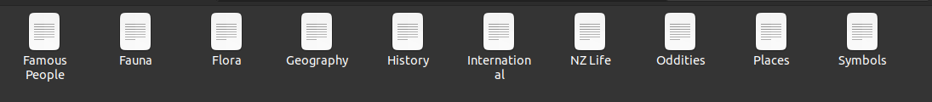

**To add new clues to existing (or new) categories**

Go to the categories folder and right click the category file you want to add clues to.  
Click “Open in Text Editor”.  
Add a new line at the bottom and enter your clue in the following format:

$$Clue_Question@Clue_Type@Clue_Answer$$

Separate the Clue_Question, Clue_Type, and Clue_Answer with an @ symbol. The Clue Question, Clue Type, and Clue Answer must not contain any @ symbols themselves, Clue_Question must not have an @ before it, Clue_Answer must not have an @ at the end, and there should be no spaces after the @ between the Clue_Question, Clue_Type, and Clue_Answer.





If your Question has multiple answers, for e.g. the Question "Name all the colours in the New Zealand flag ", will have the answer “Blue, Red, White” (irrespective of order), separate the multiple answers with a comma: $$Clue_Question@Clue_Type@Multiple_Clue_Answer_1,Multiple_Clue_Answer_2,Multiple_Clue_Answer_3$$

If your Question has various possible answers, for e.g. the Question "Name one colour in the New Zealand flag ", will have the answer “Blue”, “Red”, or “White”, separate the variations (possible answers) with a forward slash: $$Clue_Question@Clue_Type@Possible_Clue_Answer_1/Possible_Clue_Answer_2/Possible_Clue_Answer_3$$

If your Question has multiple answers, where some or all of the multiplicities have a variation, for e.g. the Question "Name two colours in the New Zealand flag ", will have the answer “Blue, Red”, “Blue, White”, or “White, Red” (irrespective of order), you can separate the multiple answers with a comma, and each variation with a forward slash: $$Clue_Question@Clue_Type@Multiple_1_Possible_Clue_Answer_1/Multiple_1_Possible_Clue_Answer_2,Multiple_2_Possible_Clue_Answer_1/Multiple_2_Possible_Clue_Answer_2$$